How to calculate the NFPA 85 Purge Volume

Rev History
0 4/12/16 Initial Issue Robert Loeven
1 4/18/16 Minor text improvements Robert Loeven
2 7/25/16 Added GT Exh Volumes Robert Loeven
Background
The introduction of the shutdown purge credit product created a desire to have smaller purge volumes. The previous GE method used for the startup purge took into account the entire HRSG and thus produced large purge volumes. These large purge volumes are more likely to cause an incomplete purge of the entire required volume during a coastdown, which results in a need to re-connect the LCI, or in the customer not obtaining the desired purge credit.

As a result, NFPA 85 volume methodology was approved for use on shutdown purge credit units. The National Fire Protection Agency 85 Standard 8.8.4.2.1 dictates how this will be calculated. The volume is equal to 5x the volume of the GT exit to the point in the HRSG where the exhaust gas temperature drops to 100F below the autoignition temperature (AIT) of the design fuel. Note that the volume must extend at least to the outlet of the first evaporator in the HRSG (see excerpt below).

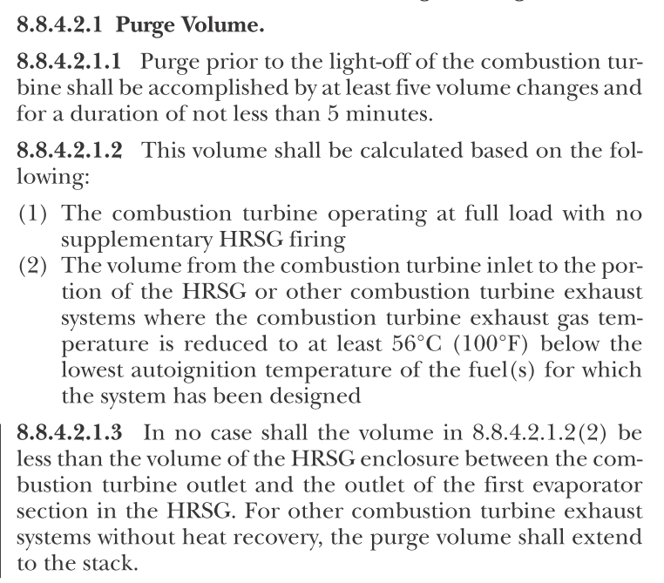
Figure 1 – Excerpt from NFPA 85, 2015 Version

Required Inputs
- Design Fuel Specification - Can be found in PLM for the specific site project
- Thermal cycle analysis of HRSG by component at base load condition
- HRSG Component volumes and tube volumes

Calculation Methodology

Please note, the preferred situation is for the customer to provide this purge volume to GE. For new units the NFPA 85 purge volume should be readily available from the HRSG vendor. Even for existing units, it is preferred to have the customer provide this calculated volume to GE. If that is not possible, the customer must agree to sign off on the NFPA 85 purge volume as calculated by GE. The detailed steps are listed below:

- Determine the auto-ignition temperature (AIT) of the design spec fuel. The fuel spec can be found in PLM for the project. If multiple fuels are used, the lowest AIT for the various fuels should be used. For duel fuel units, the gas fuel AIT value may be used if the liquid fuel source is completely isolated via air block before the formation of the gas fuel
Input the fuel constituents into the attached spreadsheet. The constituents are ordered from high to low AIT. The lowest AIT that has a red bar pop up is the one to be used. In the below example, the calculated AIT is 472 degC.
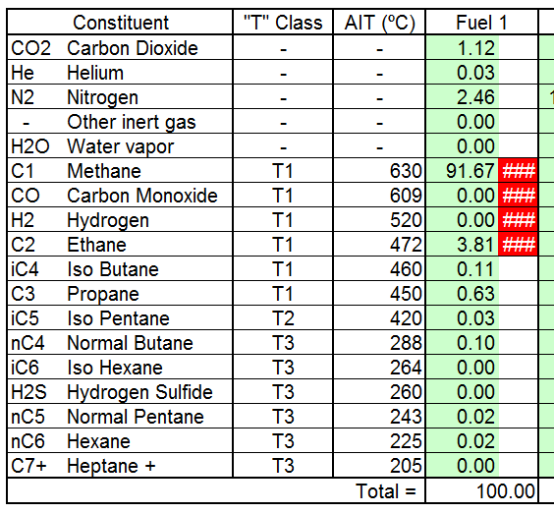

- Examine thermal cycle analysis of the HRSG to determine the location in HRSG where the exhaust gas temperature drops 56 degC (or 100F) below AIT. In the example above, we would have to determine the component where the exh gas temp drops below 416 degC. The entire volume of that component should be included in addition to the upstream volume from the GT exhaust onwards. In other words, if the desired temperature is reached in the HP evaporator, then the entire volume of the HP evaporator (and all upstream volume) must be used. Additionally, the NFPA 85 requires that the volume must be at least through the outlet of the first evaporator.

Below there is an example analysis from a particular site. The temperature drops below [AIT -56C] within the HP evaporator.
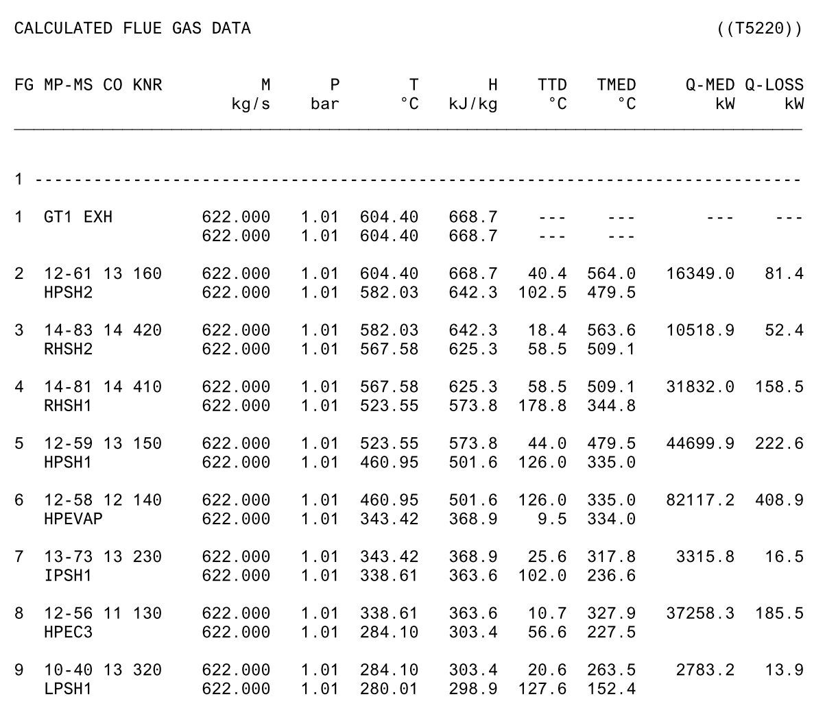

- Sum up the volume of all the required HRSG components determined in step 2. Then subtract the volume of the tubes in each of these components. If the tube volumes are not available, they can be dismissed as it make the calculated volume more conservative.
- Now the GT Exhaust frame and diffuser volume must be added to the HRSG volume which has been determined. This volume is standard by frame. See table 1 below for the appropriate volume by frame.

Table 1 – GT Exh Volumes by Frame
Frame | Exhaust volume
 | cu ft
9E.03 | 4908
9E | 4908
9E CSEPEL | 4908
9F.03 | 6427
9F.05 (9FB.03) | 7381
9HA.01 | 8015
7E.03
7F.03
7F.05 | 5395
7F.05 | 5395
7HA.01
7HA.02
6B.03 | 883
6F.03 | 1377

- Finally, the sum of the volumes from Step 3 & Step 4 is multiplied by 5. This is the NFPA purge volume. A typical 7F05 NFPA 85 purge volume for a CC plant is 540,000 ft^3.

